**DOCUMENTATION**

NAME: **SAMUEL OLUWAFEMI IFERE**

STUDENT ID: **M00424620**

PROJECT NAME: DEVELOPMENT OF **ONLINE APTITUDE TEST APPLICATION**

PROJECT SUPERVISOR: **JUDY WILSON**

# ACKNOWLEDGEMENTS

I am grateful for the overwhelming support and understanding from God, my family and friends. I will use this opportunity to acknowledge my supervisor, Judy Wilson, for her support during the time of the project. Also, I would like to say thank you to Julie Kevill of the numeracy department and Asanka of the IT department for their immerse contribution during the research period.

Finally, I would like to warmly acknowledge the module leader Peter Passmore of this course.

# 

**TABLE OF CONTENTS**

ACKNOWLEDGEMENTS 2

CHAPTER ONE 4

1.0 INTRODUCTION 4

CHAPTER TWO 7

2.0 LITERATURE REVIEW 7

2.1 Overview of Online Aptitude Test Application 7

2.1.1 Online Aptitude Test Application 7

2.1.2 Virtual Learning Environment 8

2.2 Review of Existing Research and Development 9

2.3 Review of Terminology 11

CHAPTER THREE 14

3. 0 Background Information 14

CHAPTER FOUR 17

4. 0 system analysis 17

CHAPTER FIVE 25

5.0 SYSTEM IMPLIMENTATION 25

5.1 General 25

5.2 System Overview 25

CHAPTER SIX 29

6.0 EVALUATION AND TESTING 29

6.1 Summary 29

6.2 Evaluation And Testing 31

CHAPTER SEVEN 47

7.0 CONCLUSIONS AND RECOMMENDATIONS 47

7.1 Conclusions 47

7.2 recommendations 49

CHAPTER EIGHT 50

8.0 REFERENCES 50

# CHAPTER ONE

# 1.0 INTRODUCTION

The increasing availability of computers and internet services in teaching environments to the teachers and students at nursery level to tertiary level and the need for transparency, resources distribution, and matching available capability in the late 19th century has stimulated an ever growing body of researchers to research into the need to adapt this age long psychometric test known as aptitude test for computer online aptitude testing and processing of students’ academic data in the educational sector.

It is almost difficult to avoid taking tests by a student during the student academic route [ref. 7]. Aptitude tests are given approximately daily in schools of learning. Few students reach college level without taking one form or other of intelligence test. These various forms of ability tests continue after college; which is when a choice of a career opportunity is made, one may take aptitude and psychometric tests.

Aptitude tests large scale usage was traced to the first war world in 1914. Robert Yerkes [ref. 8] persuaded the United States Army to use the aptitude test to test all recruits for intelligence. After success was achieved in using an aptitude test for the United States army intelligence recruits, it was eventually administered experimentally in 1926 to a few thousands of college applicants. This gained reputation and acceptance for examining strengths and weaknesses of applicants as the world population increases in an uncontrollable fashion with scarceness of resources and opportunities in academic and employment circles.

Before the era of information technology and fast computer hardware chips development, these tests were administered as paper based and oral. Several researches had been committed into the usefulness in adapting the paper and pencil tests into computerised aptitude tests. In the late 1980s to 1990s, the need for computerised based aptitude tests became immersed in the introduction of global market; for example bodies such as the American Psychological Association's Guidelines for Computer-Based Tests and Interpretations (1986) states: “When interpreting scores from the computerized versions of conventional tests, the equivalence of scores from computerized versions should be established and documented before using norms or cut scores obtained from conventional tests.” (p. 18) and the joint Standards for Educational and Psychological Testing (AERA, 1999) recommends empirical validation of the computerized versions of tests: “A clear rationale and supporting evidence should be provided for any claim that scores earned on different forms of a test may be used interchangeably.” (p. 57); leading to the belief that computerised aptitude tests has been evolving since 80s.

Although these growing bodies of research into the adapting of paper and pencil aptitude tests into computerised ones, have had limited researches into more useful functionalities of evolving packages than the primary function of selecting and placing candidates in a new environment.

In this research, effort will be made to develop an application that utilises other benefits of the aptitude tests in the educational system which can be adapted into the work environment.

The application created is a part of an emerging educational method, which can be viewed as a framework that enables the use of IT in learning.

The educational method referred to is called “Virtual Learning Environments or VLE’s” and has increasingly over time gained prominence in the educational sector.

1. It provides the students with a range of sources of information which are selected and organized by the tutors to ensure only relevant resources for their learning are provided.
2. It enables students to create and store digital work that can be refined as a project progresses.
3. It gives students the opportunity to reinforce aspects of their work through tests and evaluation exercises.
4. It enables students and teachers to communicate and collaborate with ease in a number of ways.
5. It enables teachers make informed appraisals on the level of understanding and assimilation of the students on relevant subjects (Ofsted, 2009).

# CHAPTER TWO

# 2.0 LITERATURE REVIEW

This project aims at developing an online aptitude test application that performs registration, login access, storage of course materials, examination test taking, identification of student areas of weakness, communication of examination test results through email and allocation of resources by using Java programming language. In order to achieve this, the Java application that will be developed should efficiently handle the following issues: user interface, database, and matching of resources.

2.1 Overview of Online Aptitude Test Application

The online aptitude test application development is the integration of the computerised version of the age long aptitude test with virtual learning environment (VLE), tailored to suit the lower tiered educational system using the Java language by taking advantage of the availability of high speed computers and internet service.

2.1.1 Online Aptitude Test Application

The Java application will create a computer based aptitude test that can be accessed online by the students through internet connection using normal web browsers. This will create a user interface for taking the tests locally or remotely through a login access registration process.

The results of the series of tests taken by the students will be used within the core Java program to analyse the students’ skill and ability in order to identify areas that more resources might be required and communicate these through emails by interfacing virtual learning environment (VLE) that houses learning resources in her database as presented in Figure 2-1 below.

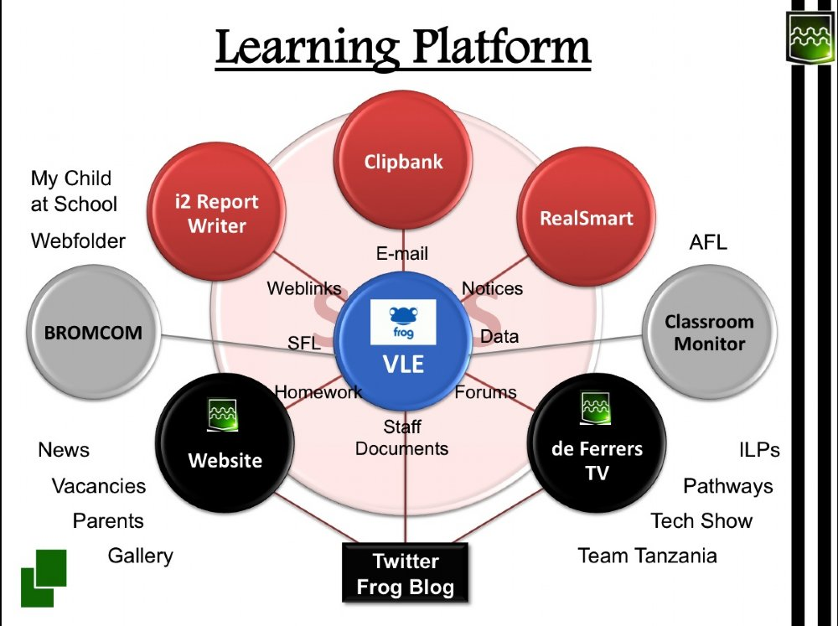

**Figure 2-1: Learning and Communicating Platform [ref 9]**

## 2.1.2 Virtual Learning Environment

A virtual learning environment can be defined as designed information spaces that leverage the routine use of computers to allow the remote access to learning materials as showed in Figure 2-2 below. The development of these began in the late nineties as a combination of communication tools and file-sharing applications. By the year 2000, the gradual introduction into the educational setting began and has gradually gained in recognition and acceptance by the educational community or providers.



**Figure 2-2: Remote Access to Learning Materials [ref. 10]**

Virtual learning environments are believed to enable teachers meet the requirements of the National curriculum more effectively because she provides the platform for the learners to do the following:

1. To provide the students with a range of sources of information which are selected and organized by the tutors to ensure only relevant resources for their learning are provided.
2. To enable students to create and store digital work that can be refined as a project progresses.
3. To give students the opportunity to reinforce aspects of their work through tests and evaluation exercises.
4. To enable students and teachers to communicate and collaborate with ease in a number of ways.
5. To enable teachers make informed appraisals on the level of understanding and assimilation of the students on relevant subjects (Ofsted, 2009).

2.2 Review of Existing Research and Development

Aptitude test computerization and virtual learning environments research and development have been running parallel since the late 90s as high speed computers and internet service technology become more available to homes and institutions of learning. This research will take a look at some of these developments and develop a Java application that will incorporate computer based aptitude test into a virtual learning environment in a single robust online application for the consumption of the lower tier (primary schools) of the educational sector.

**Parshall, et al. (**2002) throws the balance on the computer based tests and called it computer-fixed or electronic page-turners tests that contain the same items as their corresponding paper tests. That computer based test mimics the paper test with advantage of limiting the number of confounding factors when comparing test results in the two modes. For example, computer tests allow students to skip items, as well as change answers on previous items, like they may do on a paper test, which keeps possible test-taking strategies consistent across modes. One disadvantage of the computer test is that students must still encounter items that are too easy or too difficult, since the form is fixed in length and can potentially cover a large range of item difficulties.

**Wang and Kolen** (2001) argue that comparing paper tests with computer adaptive test (CAT) may restrict the advantages that computer-adaptive tests offer.

**Martha Thurlow, et al** (2010) concludes that computer-based testing (CBT) is an innovative approach to assessments which most pursued by states. That CBT is the solution to having cheaper and speedier test delivery for state and district-wide assessments. It is also seen by some as an avenue toward greater accessibility for students with disabilities. Thetechnical paper by **Martha Thurlow** listed nine key considerations for states and districts to establish the conclusions.

In Antonio G. Botella (2007), the emerging guided virtual learning environment was described as interaction that takes place in a computer classroom with beamer and audio capabilities as showed in figure 2-3 below.

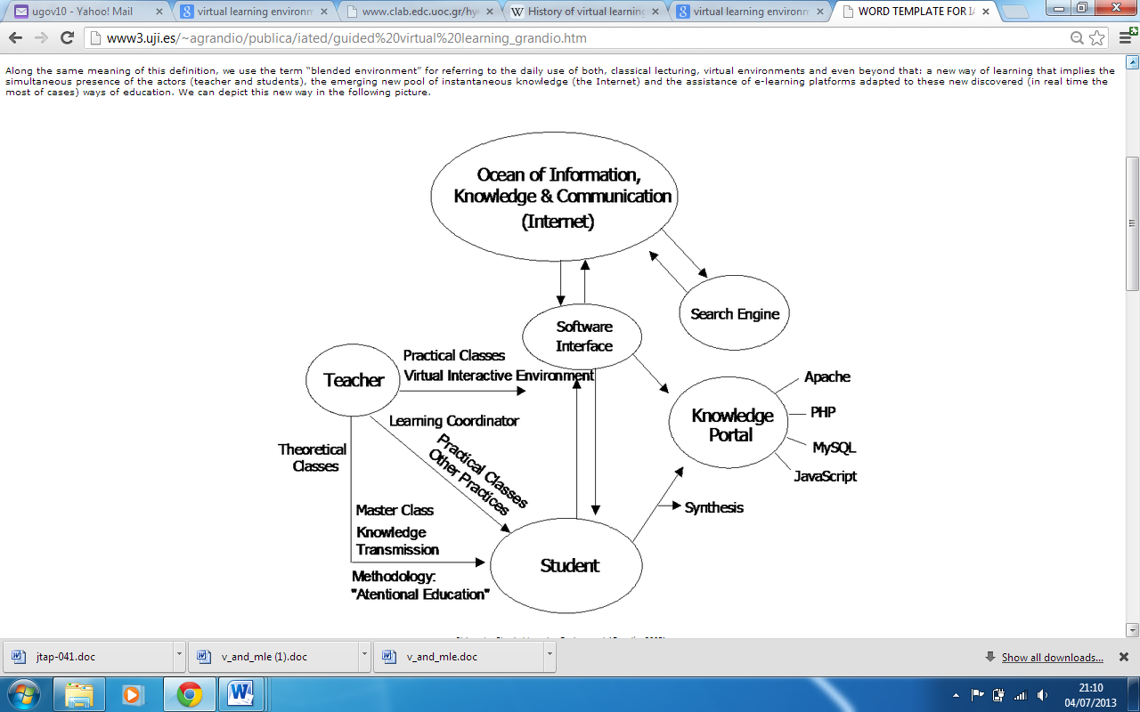.

**Figure 2-3: Blended Learning Environment (Grandío, 2006)**

Students are suggested to look for and summarise web pages guided by previous given key words in class or in the textbooks. These pages and links are inserted, viewed and listened; the teacher supervises the process and corrects it, making suggestions and introducing new information and knowledge into it. So, the teacher is included in the learning process. Both, teacher and students are involved in a learning circle. Furthermore, the learning source shifts from the teacher to be centred around the student. The teacher is no longer a knowledge transmitter. **Antonio G. Botella** concludes by referring to the daily use of both, classical lecturing, virtual environments and even as a new blended way of learning that implies the simultaneous presence of the teacher and students; “*the combination of multiple approaches to learning. For example: - self-paced, collaborative or inquiry-based study. Blended learning can be accomplished through the use of 'blended' virtual and physical resources. Examples include combinations of technology-based materials, face-to-face sessions and print materials*”.

2.3 Review of Terminology

Some frequently used terminologies associated with and apply to the functionality and development of the online aptitude test application are reviewed below according to figure 2-4.

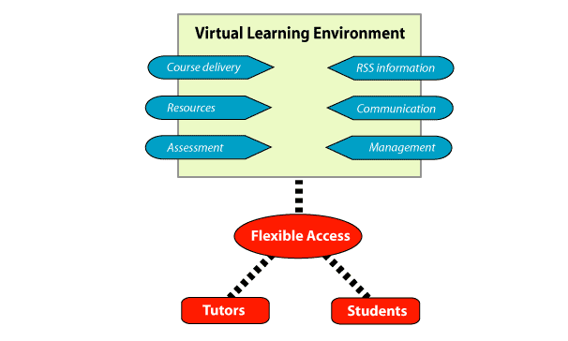

**Figure 2-4: Essential components of a VLE** (RECAP Limited, 2005-2009).

Rich Site Summary (RSS) Information:

Rich site summary (RSS) information provides easy to reach up to date general information on the events taking place within the school and programs arranged by tutors for students or students for students. It basically deals with news flashes and breaking news bulletins. It also provides tutors with updates on available professional trainings, seminars and research avenues or openings.

Course Delivery:

Course delivery deals with the course syllabus, current information on available courses to help long distant pupils because of medical or other inescapable reasons. This component also holds the results for all assessments generated from the assessment component.

Resources:

Resources provide authoring tools for tutors to create documents that would aid further reading and research for the students. It includes additional study materials whether as links to the sources or as publications and journals.

Communication:

Communication handles all forms of needed networking or collaboration between tutors and students. This could be in forms of emails, threaded discussions and chats with a tutor as the moderator, and also could optional links to social network media such as youtube.com and twitter.

Assessment:

Assessment component deals with providing a controlled environment for self-assessments, quizzes, essay submission and peer assessment. It also handles all formal assessment requirements such as examinations, project submission and assignments. The results of all forms of formal and informal assessments are delivered to the course delivery component either automatically or posted after tutors have evaluated them.

Management:

Management component aids the management access rights for tutors, their assistants, course support staff and students. It also provides statistical analysis of both individual and overall students’ performance thus reducing the work load of tutors having to deliberately work on this and documents it for administrative and quality control purposes.

# CHAPTER THREE

# 3. 0 Background Information

**3.1 Application Definition**

The development of online aptitude test application which integrates a virtual learning environment and information management; applicable to primary school education for analyzing overall students’ performance in mathematics subject is carried out using tools such as HTML, CSS, MySQL and Java.

The algorithm was developed after reviewing up to date development in computer based aptitude tests, virtual learning environment and several meetings with the numeracy department of the University and the IT department where an overview of the University oasisplus ran a simulated test version using the functions provided by the oasisplus test section.

This resulted in the application algorithm/architecture incorporating the following functionalities for the effectiveness of the application in primary school education;

1. User registration with personalized password.

2. Tutor environment (the head tutor would be the administrator) which includes:   
a) Managing user passwords, send welcome message (personalized message).  
b) Database control includes (loading new materials and modifying existing for example, numeracy, arithmetic and trigonometry)   
c) Supplying solution for problems and marking scheme   
d) Modifying test time for students based on age and group that time out student.  
e) Access to student records and marks.   
f) Directly influence resources each student requires based on academic need as study links for the students to view and use.  
g) Tool for querying students overall performance according to topics contained in the test questions (e.g. Numeracy, arithmetic). An example of this is the OCJP exam result

3. Registered student environment which includes:

a) Account management (for example change to personal data such as password, name and page message).

b) Learning environment for access typical practice questions and immediate on-screen results.

c) The students eligible to take the test should have the link enabled in their page.

d) The on-screen result should show after the students click the "submit" button with a breakdown of performance according to topics contained in the test.

The following sections below contain the detailed algorithm/architecture developed and programming process taken in developing a functional application.

**3.2 Algorithm/Architecture**

In the development of applications, N-tier architecture has been considered as more effective than one-tier architecture and two-tier architecture because N-tier architecture involves having a minimum of three (3) layers, and is implemented through component modularization. It enforces data and control access constraints. The N-tier architecture schematic is presented in figure 3-1 below.

Application Layer

Database

Interface Layer

Data Access Layer

Controller

Servlets

DAOs

**Figure 3-1: 3-Tier Architecture**

As the N-tier is more robust and is an example of Model-View-Control (MVC) architecture, it is the adopted logical design that will be used for the development of this application. Adopting this approach brings in some complexity, and increases initial development time, but will significantly improve the maintainability, extensibility, and flexibility of this application.

**3.3 Minutes of Meetings**

A meeting with Julie Kevil of the numeracy department was set-up by my supervisor (Judy Wilson) to aid me in understanding and gathering the possible requirements that would be need to create a proper educational system. In this meeting with Julie that lasted about half an hour, we discussed the possible requirements needed to make a basic mathematics testing system. These requirements are as follows:

1. Using clear instructions at the top of the test page to indicate the total time of the test and the types of questions contained in the test such as an essay section along with its input format to reduce errors in marking through spelling/typographical errors, the use of calculators, objectives questions so the student would easily adhere to them.
2. The possibility of randomizing the same test questions amongst the test candidates. The reason behind this is to reduce the chances of malpractice during the testing period.
3. The spelling or typographical errors we discussed were in the event of an essay section being provided, would the student enter answers as 53%, 53 %, or 53 percentage? Would the system automatically deal with spacing issues or should the student be made to use specified spacing methods?
4. A meeting was set-up with Asanka of the IT department to help me understand how to accomplish those features from a technical point. In this meeting with Asanka, a personalized profile was created for me within the Universities oasisplus testing application to run a simulation of the provided functionalities. I also discovered the platform the application runs on the provided by Adobe®. This gave rise to the requirements of the project mentioned below.

# CHAPTER FOUR

# 4. 0 system analysis

**4.1 Programming Process**

The application development process involves the coding of the following application units as contained in figure 3-1 in background information, chapter 3 above.

**4.2 Application Structure**

The application structure includes, JavaServer Pages, servlets, Data-Access-Object and connection class. Each of the components within the business logic coding created within the Netbeans IDE are explained below.

**JavaServer Pages**

The JavaServer Pages were developed in the Netbeans IDE using the combination of the Java programming language and HTML tags to dynamically produce HTML pages to be displayed on a Java enabled web browser which the users interact with.

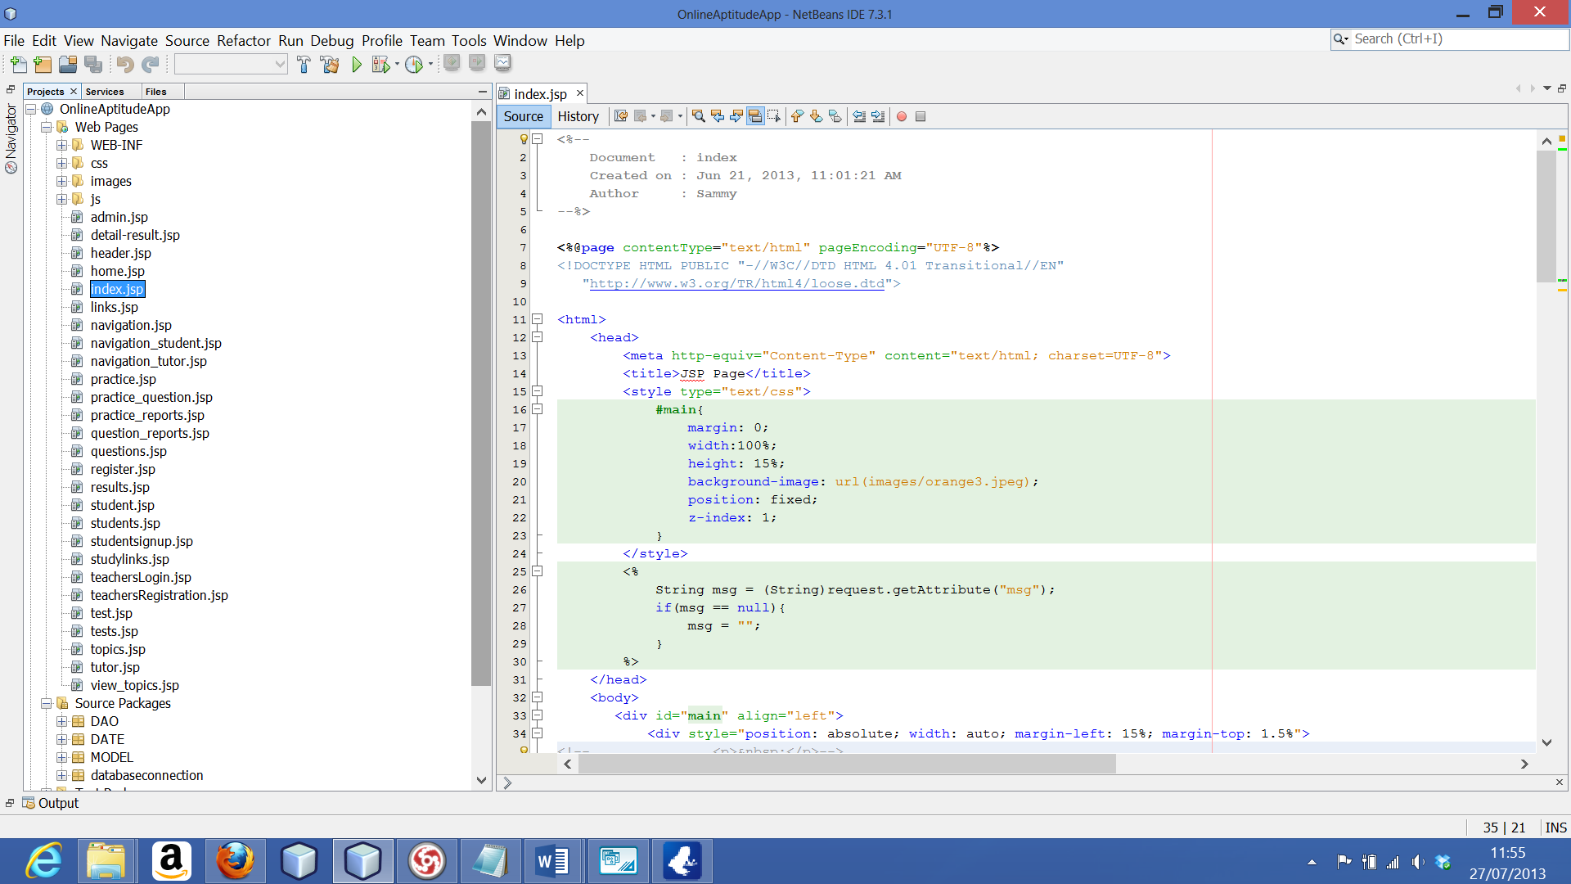

**Figure 4-1: JavaServer Pages**

**Servlets**

The servlets are developed set of Java classes in the application to handle service requests sent by the user. It connects to the application server (Glassfish server) which is the platform for running the web application and to efficiently execute the responses. This involved creating different servlets to handle different user requests and responses. Each of these servlets were tested independently of each other. These set of developed Java classes are presented in figure 4-2 below.

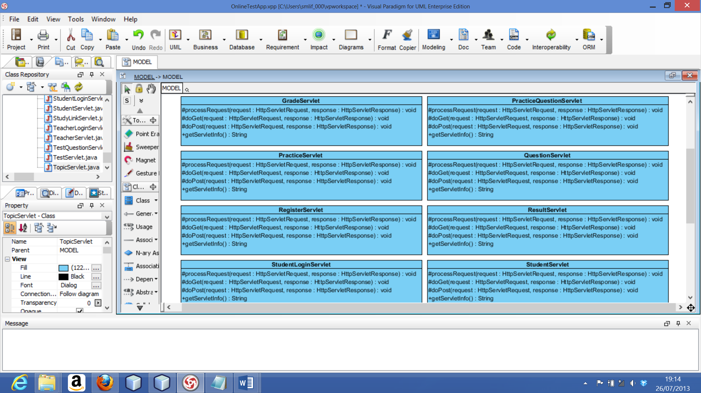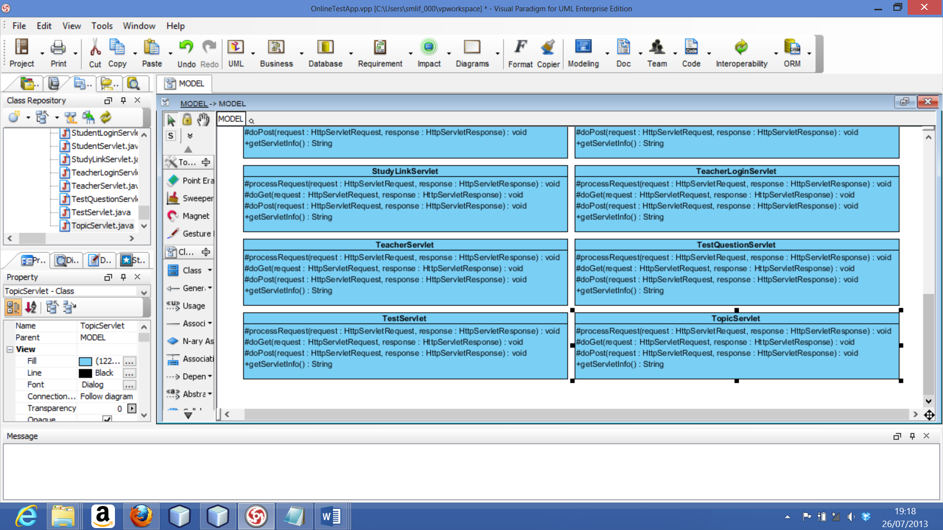**Figure 4-2: Servlets-Java Classes**

For instance when a new user fills a registration form and clicks the “submit” button, the form details are sent to the database which is linked by a connection class to the data-access-object (DAO) methods used for communicating by the servlet classes to handle user’s requests and to send a confirmation note to the user to acknowledge the successful entry of a record. Then the user is notified about the status of the request.

**Data-Access-Object (DAO)**

The data access objects are Java oriented classes created in order to connect the application to the database. They are a very important part of the application because without interaction between the interface and database, the application is not complete. After the creation of these data access objects, they were tested for functionality using the connection class. The data DAO classes are presented in figure 4-3 to figure 3-5 below.

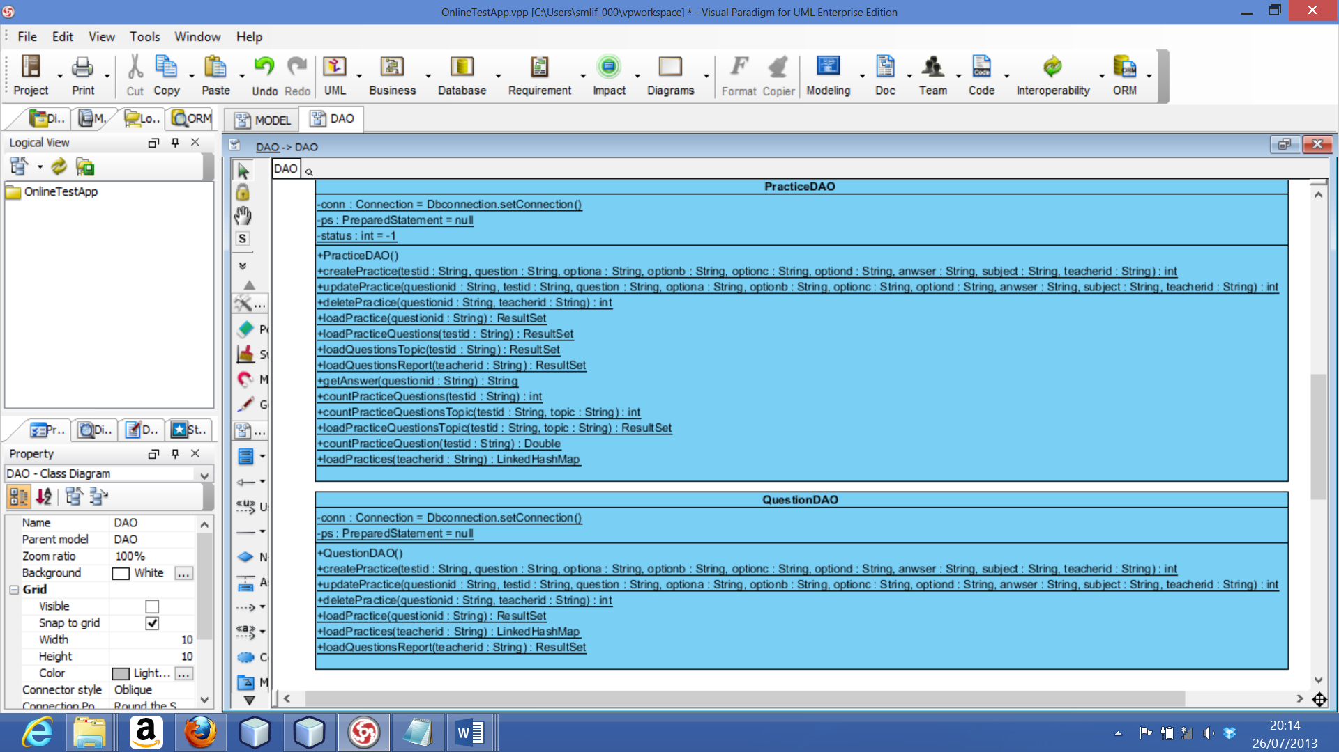**Figure 4-3: DAO –Practice and Question DAO Classes**

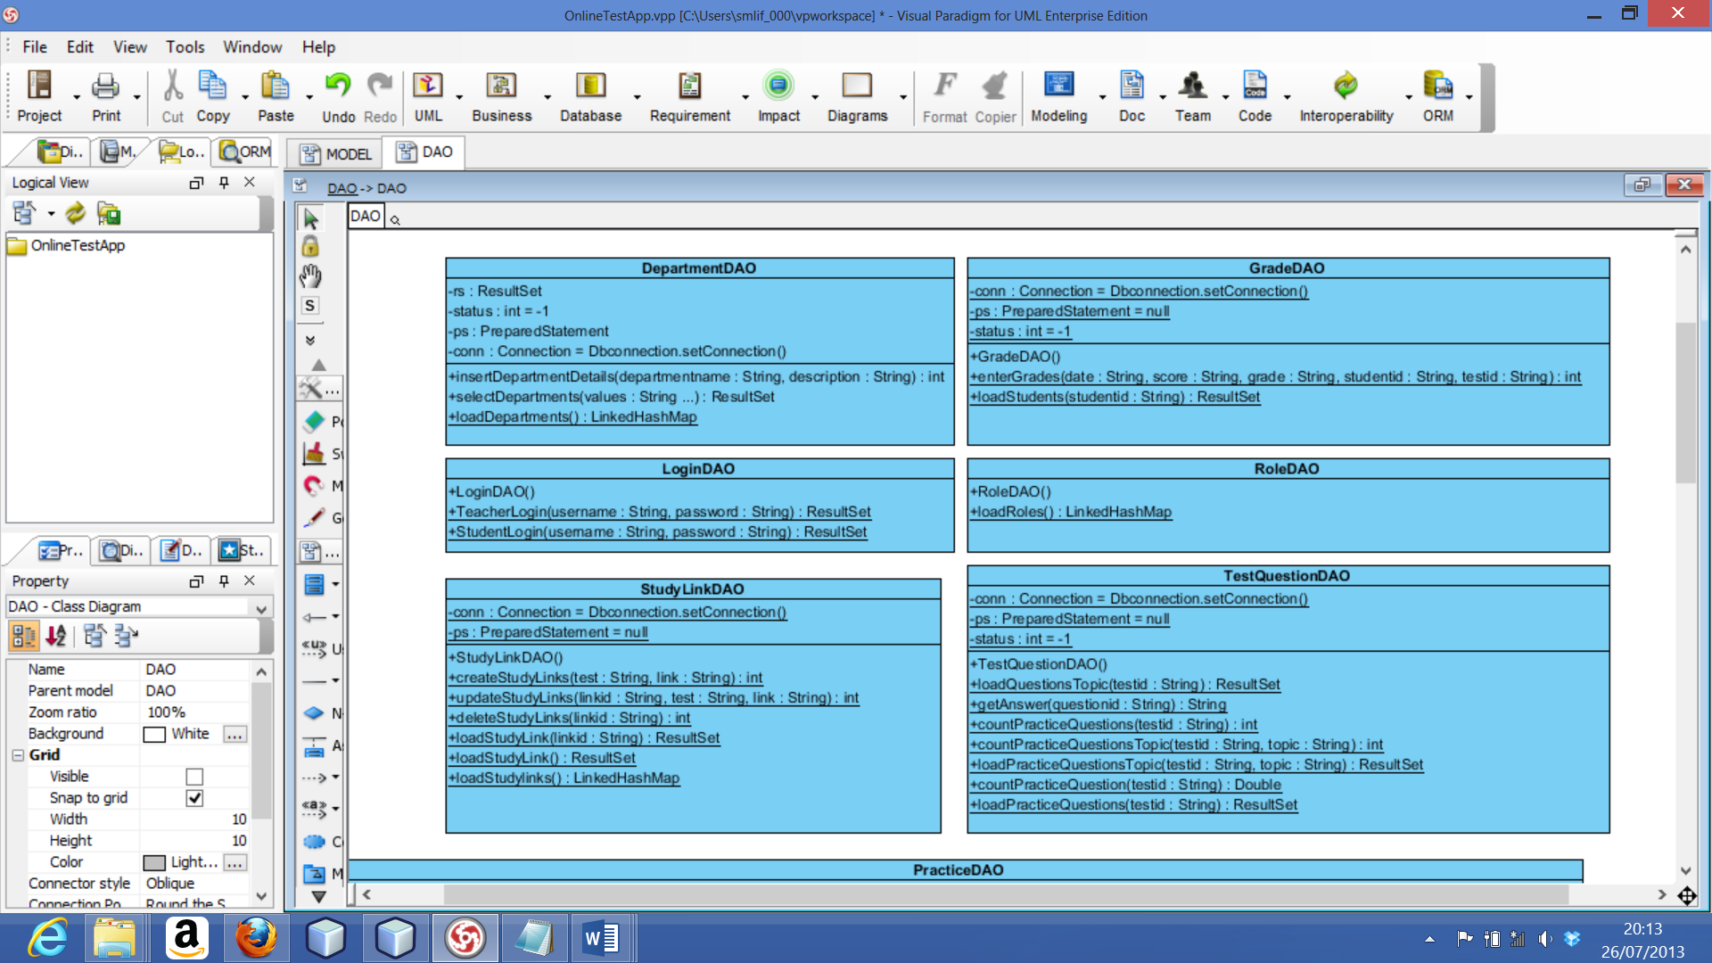**Figure 4-4: DAO –Department to Test-question DAO Classes**

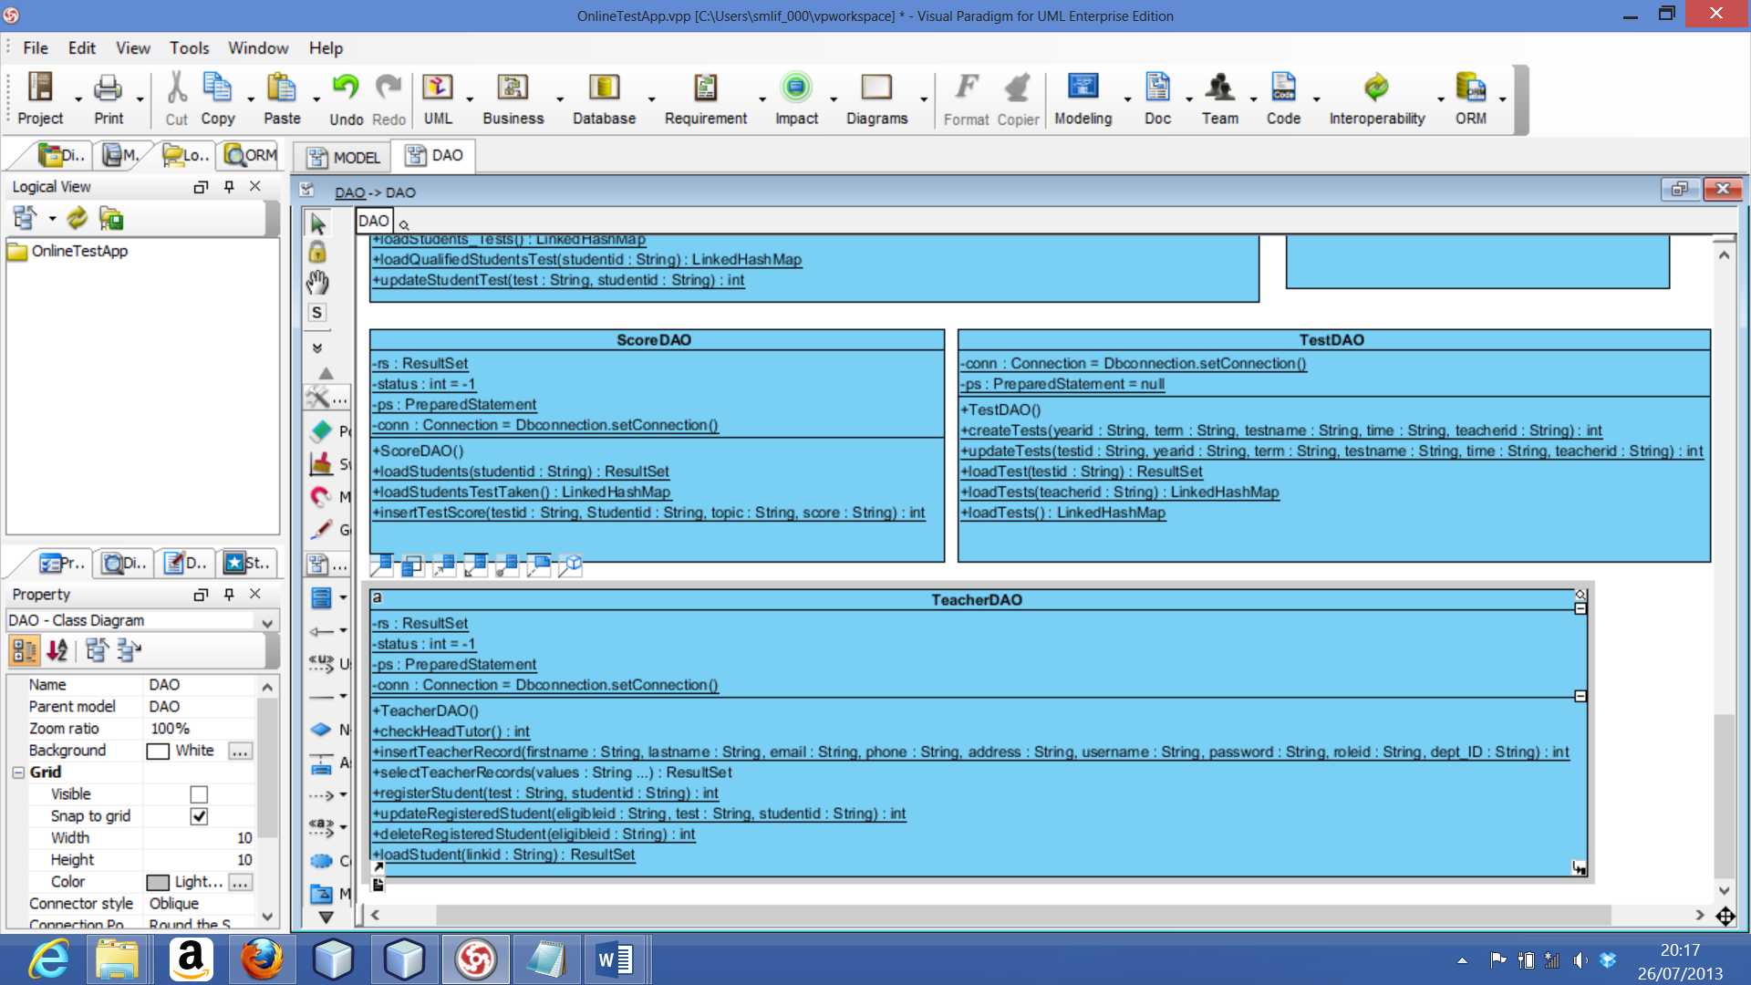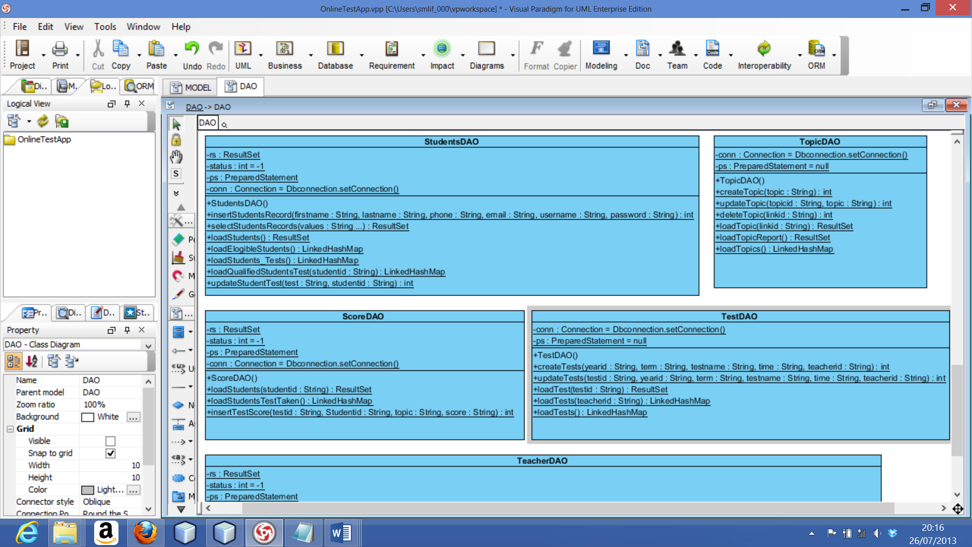**Figure 4-5: DAO –Teacher to Test DAO Classes**

It is necessary that we use these DAO’s as it implements the Model-View-Control architecture previously mentioned.

**Connection Class**

The connection class is developed to establish a link and acts as the interface between the Data-Access-Object (DAO) and the database. In this class, a connection is established using methods contained in classes within the sql package of the Java API. These classes include: Connection class, DriverManager class and SQLException class.

After its creation, the class was tested and a feedback was sent with the message Connection Successful.

* 1. **Database**

The application’s database was developed using MySQL database system which runs on the Windows-Apache-MySQL-Php (WAMP) server as a relational database management system to store all retrievable data for data analysis. This involves using SQL scripting language to create the storage container (tables) which exists in form of rows and columns for performing query operations.

The relational database management system has tables within a specific database created to establish an entity relationship that can be graphically represented using an entity relationship diagram (ER-D). The relationship between one table and another table within the application database are indicated by cardinalities. The cardinalities in the application database are: one-to-one (1 ↔ 1), one-to-many (1 ↔ 1…*), many-to-one (1… * ↔ 1), and many-to-many (1…* ↔ 1…*) which form the complete entity relationship diagram figure 4-6.

The database was scripted using the phpMyAdmin page provided by the WAMP server to make it case sensitive and can be auto-incremented for each unique ID generated within the tables to ensure data integrity during the operation of the application as a whole. Figure 4-6 below presents the application database entity relationship diagram.

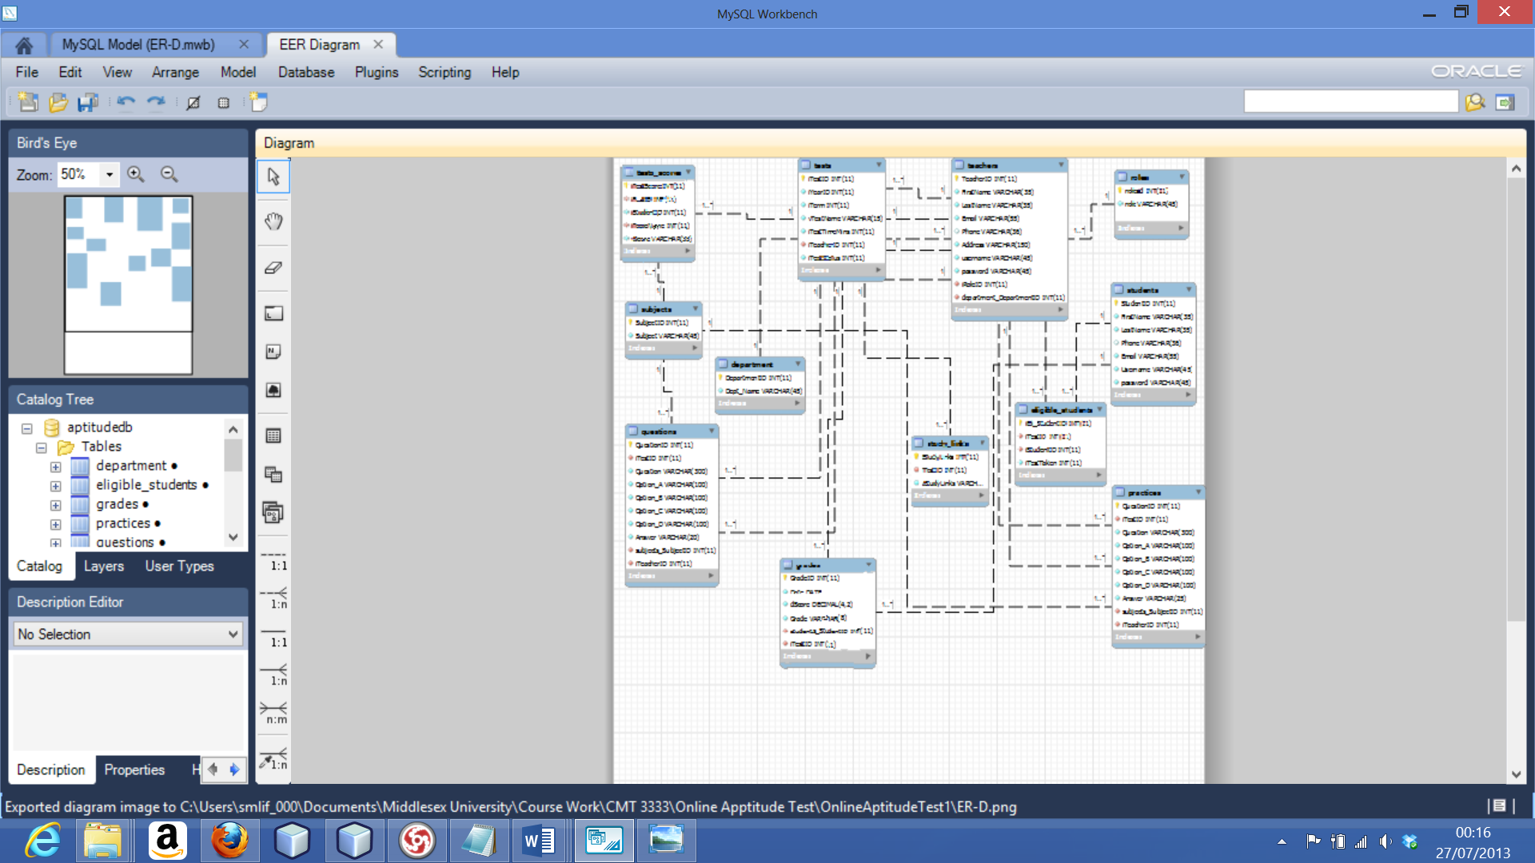**Figure 4-6: Entity Relationship Diagram (ER-D)**

The database contains of twelve (12) tables namely: Teachers, Students, Subjects, Department, Questions, Roles, Study-link, Practices, Grades, Tests, Tests-score and Eligible-student.

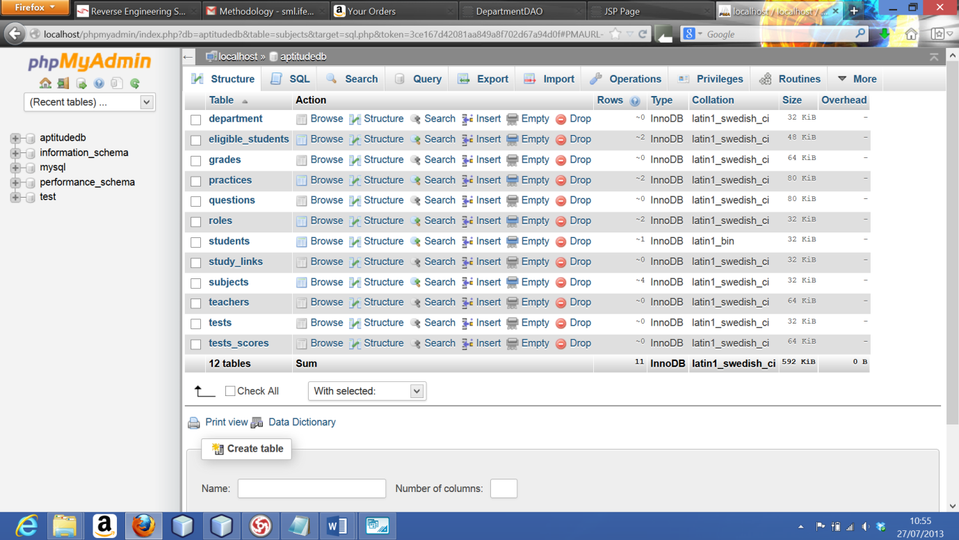

**Figure 4-7: PhpMyAdmin MySQL Database Page**

# CHAPTER FIVE

# 5.0 SYSTEM IMPLIMENTATION

# 5.1 General

The first part describes the hardware and software used to develop the system and provide the overview of the overall structure. Then, the next part depicts the functionality along with the flow of data among top-level components regarding the prototype.

The following hardware components were used in developing the prototype system:

1. One Laptop Computer: Dell Inspiron 15R SE 7520.
2. Intel Core i7 CPU.
3. 16GB DDR3 RAM.
4. AMD Radeon HD 7730M 2048MB.

The system uses the following libraries and software to execute:

1. Netbeans 7.3.1 (IDE) Integrated Development Environment as development environment
2. Java EE 6 API’s
3. GlassFish Server 4 as the web container.
4. MySQL JDBC Driver for the database connectivity.

# 5.2 System Overview

This system has only two profiles created which are the Tutor and Student profiles. It utilizes a HTML page with input fields to receive data such as the username, password, first name, last name, email, and phone number from a new student user and the username, password, first name, last name, email, phone number, address, department, and role from a new tutor user. These are shown in the pictures below:

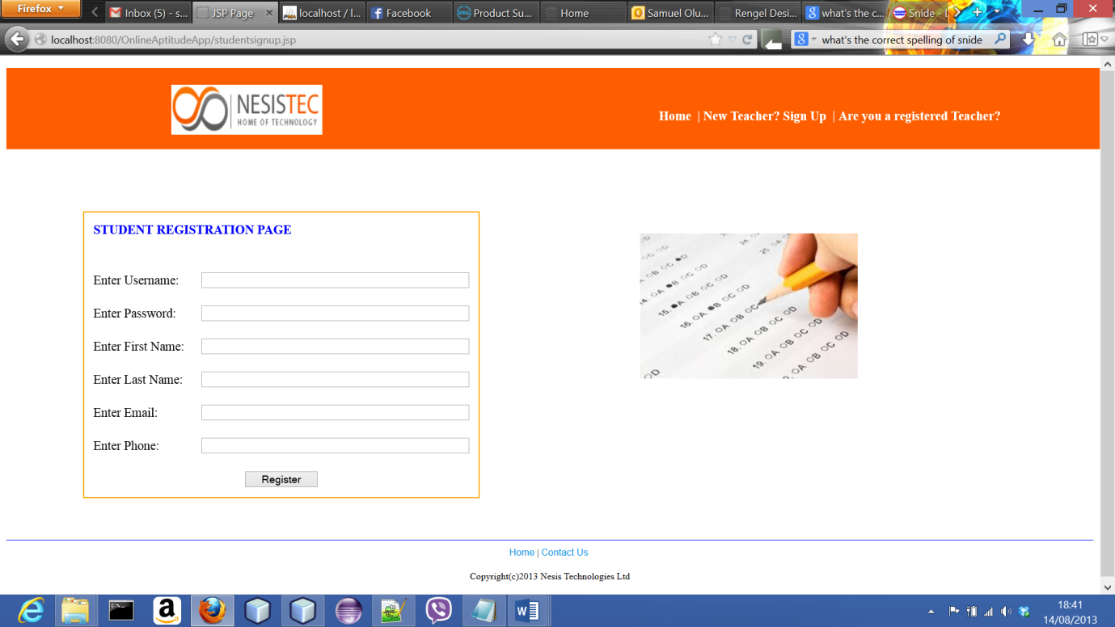

**Figure 5-1: Fresh Login Page for Students**

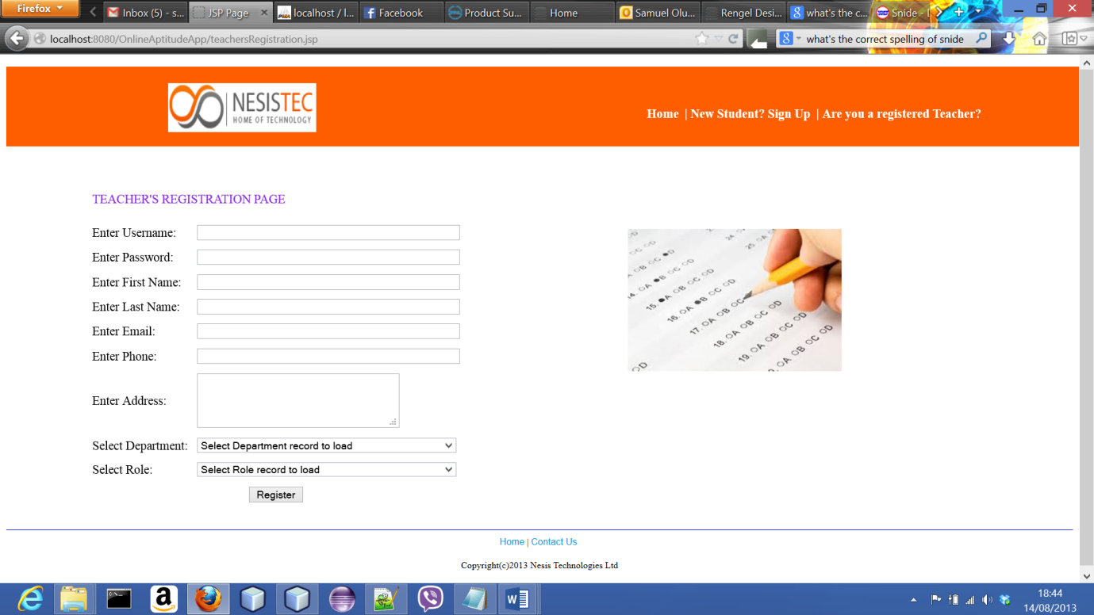

**Figure 5-2: Fresh Login Page for Tutors**

After a new user registers in any of the two provided profiles, the system automatically returns the user to the required login page for the user to login using the username and password provided during registration. When the user logs in, the system uses Sessioncookies to identify the user and the profile in which the user registered in. The Sessioncookies does this by going into the database to search for the username and password which the user provided and returns these set of values to the requested pages.

**Tutor Profile:**

This profile has two major login privileges:

* Head tutor
* Regular tutor

The difference between the head tutor privilege and the regular tutor is, the head tutor being the system’s administrator can create the topics to be taught for that academic session while the regular tutor does not have such options available to them. The system would recognise only one head tutor and rejects any other attempt to create a new head tutor once it has one already registered.

Their similarities are as follows:

1. Create a question bank for both practice and test questions.

While creating the tests questions, the tutor has to provide the answer option from the options supplied otherwise, the system would flag an error. This is done by comparing the answer option to the supplied options to check for a match when it returns true then the question is entered into the database.

1. View and register a student for as many tests as required.

This can only be achieved when students have registered within the system because, it would load the names of those students from their list within the database via a combo box text field.

1. View the test results of the students they registered for a test by topics and grades.
2. Provide study links for students tied to the tests that a tutor creates and cannot do this for the practice questions option.

**Student Profile:**

This profile within the system allows the user do the following:

1. Register as a new user and login with the username and password as provided on registration.
2. Take as many tests as registered for by their tutors.
3. View on-screen marks after clicking the submit button on the test page according to the topics set by the tutors allocating percentages to each topic then an overall percentage.

This the system does by picking the question ID and the option chosen as the answer along with its ID which is used to return the answer the tutor provided and checks for a match, the result of the check is registered. It does that for all the questions also, it does a check according to topics. After all those checks have been performed, it calculates the percentages and grades determined using the percentages obtained. These it then stores in the database against that student’s records.

1. View and use the personalized study links provided by the tutor for any specific test.
2. Utilize the practice test questions provided by their tutors.

Data integrity was enforced within the system by making the database case sensitive using SQL scripting.

# CHAPTER SIX

# 6.0 EVALUATION AND TESTING

# 6.1 Summary

The summary of the evaluation and testing are presented below;

1. The overall outcome of this evaluation shows that both profiles have a very high usability potential and is expected to give a wonderful user experience the system.

Each of the tasks were thoroughly scrutinized for their ease of use and clarity of purpose which are the major expectations amongst others from a system that would have to interact with users on a consistent daily basis.

1. The application has issues of proper security implementation because, both the tutors and students login links are visible to both tutors and students. This can become an issue because, a student can decide to create a fictitious tutor account and automatically have all the privileges a regular tutor has within the system. Though this is an issue, not much damage can be done as most of the records within the system are in read-only format.
2. There's an issue with having clear instructions on the test page which is intended to aid proper utilization of the test features. Also, the system doesn't give the students a chance to review their answers before submitting so even if the students were to mistakenly click the submit button, it would immediately do so without first displaying a confirmation message and options to continue or cancel.
3. Though the topics covered within the system are the main headings taught and approved for the Key Stage 3 learning level, they all contain sub-headings which could have been used to do a detailed analysis of the individual and overall performance of the students. This would further aid the tutor in knowing the very specific study links to provide for the students to utilize and also know how to design alternative methods of teaching those aspects.
4. In creating the questions bank for both the practice and test options, whenever it fails to insert a question, it doesn't s say why the failure occurred so the user would make adequate adjustments and avoid such errors in future usage.

**Figure 6-1: Tutor Profile Chart**

**Figure 6-2: Student Profile Chart**

# 6.2 Evaluation and Testing

The evaluation method used is the cognitive walkthrough. This method does not require a potential user to test-run the system yet deals with issues of usability. It handles this by creating what are called “happy paths” which are series of steps needed to complete specific tasks within the system. The steps listed if numerous, already reveals errors in the design of the system. These series of steps are each tested using four questions that deal with definite areas of usability for a potential user. (Dr. Travis, 2013)

For the purpose of a graph which would be provided at the end of this document to depict the specific and overall systems usability to a potential user, a percentage calculation is provided below. It would show for both the negative and positive aspects of the task’s evaluation.

Formula:

Total number of evaluation process =

(Number of processes within a task) x (the four questions)

Negative percentage =

(Negative comments)/ (total number of evaluation process) x 100

Positive percentage =

(Positive comments)/ (total number of evaluation process) x 100

These questions include:

**Question 1:**

Would the user be realistically trying to perform this action?

* This seeks to deal with interfaces that make unrealistic assumptions about the level of knowledge or experience the user possesses.

**Question 2:**

Is the control for this action visible?

* This aims at identifying problems with hidden controls thus making it difficult to carry out that specific action with ease.

**Question 3:**

Is there a strong link between the control and the action it claims to be able to do?

* This seeks to identify issues with ambiguous or jargon terms, comparing that with other controls that look like a better choice.

**Question 4:**

Does the system provide appropriate feedback?

* This helps to identify problems of feedback from the system to the user by checking if it is missing, easy to miss, too brief, poorly worded, inappropriate or ambiguous.

To utilize this method, a series of questions have been generated based on the features currently available within the two distinct yet linked profiles of the tutor and student along with their corresponding “happy paths” that provide answers to them. (Dr. Travis, 2013)

**Tutor profile:**

**Task 1:** What steps are required to register a new tutor?

1. Click on the link labelled “New Teacher? Sign Up”
2. Enter username and password of choice
3. Provide personal details
4. Select department from “Select Department” combo box text field
5. Select role from “Select Role” combo box text field
6. Click the “Register” button

**Task 2:** What steps are required to login after registration?

1. Enter username and password
2. Click the “Login” button

**Task 3:** What steps are required by the head tutor to create the relevant approved topics?

1. Enter username and password
2. Click the “Login” button
3. Click the “Topics” option on the side-pane provided
4. Click the “Manage Topics” sub-option
5. Type the topic title in the “Enter Topic” text field
6. Click the “Enter Topic” button
7. Click the “Logout” menu on the side-pane to sign out

**Task 4:** What steps are required by the head tutor to manage the topics?

1. Enter username and password
2. Click the “Login” button
3. Click the “Topics” option on the side pane
4. Click the “Manage Topics” sub-option
5. Select a topic from the combo box text field
6. Click on the “Load” button beside the combo box text field
7. Make the correction/ update in the “Enter Topic” text field
8. Click on the “Update” or “Delete” button
9. Click the “Logout” menu on the side-pane to sign out

**Task 5:** What steps are required to create a test?

1. Enter username and password
2. Click the “Login” button
3. Click the “Tests” option on the side pane
4. Click the “Create Test/Set Time” sub-option
5. Select the “Year” and “Term” from their respective combo box text field
6. Enter the test description in the “Enter Test description” text field
7. Enter the test duration in the “Enter Test Duration(in minutes)” text field
8. Click the “Create” button then,
9. Click on the “Test Questions” sub-option on the side-pane
10. Click on the “Manage Questions” sub-option
11. Select the “Test” and “Topic” from their respective combo box text field
12. Enter the question and its answer options in their respective text fields
13. Click the “Enter Question” button
14. Click the “Logout” menu on the side-pane to sign out

**Task 6:** What steps are required to create a practice test?

1. Enter username and password
2. Click the “Login” button
3. Click the “Tests” option on the side pane
4. Click the “Create Test/Set Time” sub-option
5. Select the “Year” and “Term” from their respective combo box text field
6. Enter the test description in the “Enter Test description” text field
7. Enter the test duration in the “Enter Test Duration(in minutes)” text field
8. Click the “Create” button
9. Click the “Practice Question” sub-option
10. Click the “Manage Questions” sub-option
11. Select the “Test” and “Topic” from their respective combo box text field
12. Enter the question and its answer options in their respective text fields
13. Click the “Enter Question” button
14. Click the “Logout” menu on the side-pane to sign out

**Task 7:** What steps are required to manage the test created?

1. Enter username and password
2. Click the “Login” button
3. Click the “Tests” option on the side pane
4. Click the “Practice Question” sub-option
5. Click the “Manage Questions” sub-option from the drop down
6. Select the “Test” and “Topic” from their respective combo box text field
7. Select the question from the combo box text field
8. Click on the “Load” button beside the combo box text field
9. Edit the question within the respective text fields
10. Click either the “Update” or “Delete" button
11. Click the “Logout” menu on the side-pane to sign out

**Task 8:** What steps are required to register a student for a test?

1. Enter username and password
2. Click the “Login” button
3. Click the “Tests” option on the side pane
4. Click the “Test Questions” drop down sub-option
5. Click the “Register Students” drop down sub-option
6. Select the “Test” and “Student” from their respective combo box text field
7. Click the “Enter Student” button
8. Click the “Logout” menu on the side-pane to sign out

**Task 9:** What steps are required to view students test results and grades?

1. Enter username and password
2. Click the “Login” button
3. Click the “Tests” option on the side pane
4. Click the “View Test Results” sub-option

Or for the grades,

1. Click the “Test Performance” option on the side pane
2. Click on the “View grades” sub-option
3. Click the “Logout” menu on the side-pane to sign out

**Task 10:** What steps are required to provide study links for tests created?

1. Enter username and password
2. Click the “Login” button
3. Click the “Tests” option on the side pane
4. Click on the “Manage Study Links” sub-option
5. Select “Test” from drop down menu
6. Insert the study link into the “Enter Study Links” text field
7. Click the “Enter Link” button
8. Click the “Logout” menu on the side-pane to sign out

**Student profile:**

**Task 1:** What steps are required for a new student to register?

1. Click on the link labelled “New Student? Sign Up”
2. Enter Username and password of choice
3. Provide personal details
4. Click “Register” button

**Task 2:** What steps are required to login after registration?

1. Enter username and password
2. Click the “Login” button
3. Personalized home page opens

**Task 3:** What steps are required to utilize the practice questions?

1. Enter username and password
2. Click the “Login” button
3. Click the “Practice” option on the side pane
4. Click the “Practice Now” sub-option
5. Select the test from combo box text field
6. Click on the “Load” button beside the combo box text field
7. Click the “Logout” option on the side pane to sign-out

**Task 4:** What steps are required to take a test?

1. Enter username and password
2. Click the “Login” button
3. Click the “Tests” option on the side pane
4. Click the “Take Test Now” sub-option
5. Select the test from combo box text filed
6. Click on the “Load” button beside the combo box text filed
7. Click the “Logout” option on the side pane to sign-out

**Task 5:** What steps are required to view both tests results?

1. Enter username and password
2. Click the “Login” button
3. Click the “Tests” option on the side pane
4. Click on the “Take Test Now” sub-option
5. Select the test from combo box text field
6. Click on the “Load” button beside the combo box text field
7. Click the “Submit” after taking test to view result

While for the practice questions result,

1. Enter username and password
2. Click the “Login” button
3. Click the “Practice” option on the side pane
4. Click on the “Practice Now” sub-option
5. Select the test from combo box text field
6. Click on the “Load” button beside the combo box text field
7. Click the “Submit” after taking test to view result
8. Click the “Logout” option on the side pane to sign-out

**Task 6:** What steps are required to view study links and use study links?

1. Enter username and password
2. Click the “Login” button
3. Click the “Study Links” option on the side pane
4. Click on the “View Links” sub-option
5. Click the “Logout” option on the side pane to sign-out

After formulating the series of steps needed to complete those tasks listed above, each of the series of steps would be evaluated using those four questions mentioned that form the framework for this evaluation method.

**Tutor Profile**

**Task 1:**

This task would therefore be achieved with a high degree of ease though there has been identified issues of validation feedback to the user where the system should able to check input strings from the respective username, password, and the personal details fields as they are typed to the already provided ones. This would aid the user of the system make needed corrections so as to have a smooth experience while performing this task. Furthermore, there was also the issue of feedback from the system in regards to the success of the registration.

Total number of evaluation processes is 24 (6 x 4)

Negative comments percentage is 12.5% from (3/24 x 100%)

Positive comments percentage is 87.5% from (21/24 x 100%)

**Task 2:**

This task would therefore be achieved with a high degree of ease though there has been identified issues of validation feedback to the user where the system should able to check input strings from the respective username and password fields as they are typed to the already provided ones. This would aid the user of the system make needed corrections so as to have a smooth experience while performing this task.

Total number of evaluation processes is 8 (2 x 4)

Negative comments percentage is 12.5% from (1/8 x 100%)

Positive comments percentage is 100% from (7/8 x 100%)

**Task 3:**

This task would therefore be achieved with a high degree of ease though there has been identified issues of validation feedback to the user where the system should able to check input strings from the respective username and password fields as they are typed to the already provided ones. This would aid the user of the system make needed corrections so as to have a smooth experience while performing this task.

Furthermore, issues where identified with the visibility and feedback of the “Enter Topic” text field. This was left rather than being corrected because with constant use, it would cease to be an issue for a user.

Total number of evaluation processes is 24 (6 x 4)

Negative comments percentage is 12.5% from (3/24 x 100%)

Positive comments percentage is 87.5% from (21/24 x 100%)

**Task 4:**

This task would therefore be achieved with a high degree of ease though there has been identified issues of validation feedback to the user where the system should able to check input strings from the respective username and password fields as they are typed to the already provided ones. This would aid the user of the system make needed corrections so as to have a smooth experience while performing this task.

Furthermore, issues where identified with the visibility and feedback of the “Enter Topic” text field. This was left as is instead of being corrected because with constant use, it would cease to be an issue for a user.

Another issue identified had to do with the combo box text field provided which makes a somewhat unrealistic assumption as to the knowledge of the user, though visible seemed quite hidden due to a lack of description, and also there is a lack of proper terms in description because none is present.

Total number of evaluation processes is 32 (8 x 4)

Negative comments percentage is 18.75% from (6/32 x 100%)

Positive comments percentage is 81.25% from (26/32 x 100%)

**Task 5:**

This task would therefore be achieved with a high degree of ease though there has been identified issues of validation feedback to the user where the system should able to check input strings from the respective username and password fields as they are typed to the already provided ones. This would aid the user of the system make needed corrections so as to have a smooth experience while performing this task.

Furthermore, issues where identified with the feedback of the “Enter Test Description” and “Enter Test Duration (in Minutes)” text fields respectively. These feedback issues could be dealt with in a similar way as that of the username and password by making the system validate the inputs from a user.

Total number of evaluation processes is 56 (14 x 4)

Negative comments percentage is 5.36% from (3/56 x 100%)

Positive comments percentage is 94.64% from (53/56 x 100%)

**Task 6:**

This task would therefore be achieved with a high degree of ease though there has been identified issues of validation feedback to the user where the system should able to check input strings from the respective username and password fields as they are typed to the already provided ones. This would aid the user of the system make needed corrections so as to have a smooth experience while performing this task.

Furthermore, issues where identified with the feedback of the “Enter Test Description” and “Enter Test Duration (in Minutes)” text fields respectively. These feedback issues could be dealt with in a similar way as that of the username and password by making the system validate the inputs from a user.

Total number of evaluation processes is 56 (14 x 4)

Negative comments percentage is 5.36% from (3/56 x 100%)

Positive comments percentage is 94.64% from (53/56 x 100%)

**Task 7:**

This task would therefore be achieved with a high degree of ease though there has been identified issues of validation feedback to the user where the system should able to check input strings from the respective username and password fields as they are typed to the already provided ones. This would aid the user of the system make needed corrections so as to have a smooth experience while performing this task.

Furthermore, issues where identified with the lack of feedback while editing the questions. This was left as is instead of being corrected because with constant use, it would cease to be an issue for a user.

Another issue identified had to do with the combo box text field provided which makes a somewhat unrealistic assumption as to the knowledge of the user, though visible seemed quite hidden due to a lack of description, and also there is a lack of proper terms in description because none is present.

Total number of evaluation processes is 52 (13 x 4)

Negative comments percentage is 9.615% from (5/52 x 100%)

Positive comments percentage is 90.385% from (47/52 x 100%)

**Task 8:**

This task would therefore be achieved with a high degree of ease though there has been identified issues of validation feedback to the user where the system should able to check input strings from the respective username and password fields as they are typed to the already provided ones. This would aid the user of the system make needed corrections so as to have a smooth experience while performing this task.

Total number of evaluation processes is 28 (7 x 4)

Negative comments percentage is 3.57% from (1/28 x 100%)

Positive comments percentage is 96.43% from (27/28 x 100%)

**Task 9:**

This task would therefore be achieved with a high degree of ease though there has been identified issues of validation feedback to the user where the system should able to check input strings from the respective username and password fields as they are typed to the already provided ones. This would aid the user of the system make needed corrections so as to have a smooth experience while performing this task.

Total number of evaluation processes is 28 (7 x 4)

Negative comments percentage is 3.57% from (1/28 x 100%)

Positive comments percentage is 96.43% from (27/28 x 100%)

**Task 10:**

This task would therefore be achieved with a high degree of ease though there has been identified issues of validation feedback to the user where the system should able to check input strings from the respective username and password fields as they are typed to the already provided ones. This would aid the user of the system make needed corrections so as to have a smooth experience while performing this task. Furthermore, issues where identified with the lack of feedback while entering the study links. This was left as is instead of being corrected because with constant use, it would cease to be an issue for a user.

Total number of evaluation processes is 32 (8 x 4)

Negative comments percentage is 6.25% from (2/32 x 100%)

Positive comments percentage is 93.75% from (30/32 x 100%)

**Figure 6-3: Tutor Profile Chart**

The mean efficiency value for the Tutor profile =

(The difference of each task)/ (total number of tasks)

= 75 + 75 + 75 + 62.5 + 89.28 + 89.28 + 80.77 + 92.86 + 92.86 + 87.5/ 10 = **82%**

This means this profile would have a very high level of usability in spite of the several issues with the validation of stringed input and lack of description for the combo box text fields except that provided within.

**Student Profile**

**Task 1:**

This task would therefore be achieved with a high degree of ease though there has been identified issues of validation feedback to the user where the system should able to check input strings from the respective username, password, and the personal details fields as they are typed to the already provided ones. This would aid the user of the system make needed corrections so as to have a smooth experience while performing this task. Furthermore, there was also the issue of feedback from the system in regards to the success of the registration.

Total number of evaluation processes is 20 (5 x 4)

Negative comments percentage is 12.5% from (4/20 x 100%)

Positive comments percentage is 87.5% from (15/20 x 100%)

**Task 2:**

This task would therefore be achieved with a high degree of ease though there has been identified issues of validation feedback to the user where the system should able to check input strings from the respective username and password fields as they are typed to the already provided ones. This would aid the user of the system make needed corrections so as to have a smooth experience while performing this task.

Total number of evaluation processes is 8 (2 x 4)

Negative comments percentage is 3.57% from (1/8 x 100%)

Positive comments percentage is 96.43% from (7/8 x 100%)

**Task 3:**

This task would therefore be achieved with a high degree of ease though there has been identified issues of validation feedback to the user where the system should able to check input strings from the respective username and password fields as they are typed to the already provided ones. This would aid the user of the system make needed corrections so as to have a smooth experience while performing this task.

Furthermore, an issue was identified with the combo box text field provided which makes a somewhat unrealistic assumption as to the knowledge of the user, though visible seemed quite hidden due to a lack of description, and also there is a lack of proper terms in description because none is present.

Total number of evaluation processes is 24 (6 x 4)

Negative comments percentage is 16.67% from (4/24 x 100%)

Positive comments percentage is 83.33% from (20/24 x 100%)

**Task 4:**

This task would therefore be achieved with a high degree of ease though there has been identified issues of validation feedback to the user where the system should able to check input strings from the respective username and password fields as they are typed to the already provided ones. This would aid the user of the system make needed corrections so as to have a smooth experience while performing this task.

Furthermore, an issue was identified with the combo box text field provided which makes a somewhat unrealistic assumption as to the knowledge of the user, though visible seemed quite hidden due to a lack of description, and also there is a lack of proper terms in description because none is present.

Total number of evaluation processes is 28 (7 x 4)

Negative comments percentage is 14.29% from (4/28 x 100%)

Positive comments percentage is 85.71% from (24/28 x 100%)

**Task 5:**

This task would therefore be achieved with a high degree of ease though there has been identified issues of validation feedback to the user where the system should able to check input strings from the respective username and password fields as they are typed to the already provided ones. This would aid the user of the system make needed corrections so as to have a smooth experience while performing this task.

Furthermore, an issue was identified with the combo box text field provided which makes a somewhat unrealistic assumption as to the knowledge of the user, though visible seemed quite hidden due to a lack of description, and also there is a lack of proper terms in description because none is present.

Total number of evaluation processes is 60 (15 x 4)

Negative comments percentage is 11.67% from (7/60 x 100%)

Positive comments percentage is 88.33% from (53/60 x 100%)

**Task 6:**

This task would therefore be achieved with a high degree of ease though there has been identified issues of validation feedback to the user where the system should able to check input strings from the respective username and password fields as they are typed to the already provided ones. This would aid the user of the system make needed corrections so as to have a smooth experience while performing this task.

Total number of evaluation processes is 20 (5 x 4)

Negative comments percentage is 5% from (1/20 x 100%)

Positive comments percentage is 95% from (19/20 x 100%)

**Figure 6-4: Student Profile Chart**

The mean efficiency value for the Tutor profile =

(The difference of each task)/ (total number of tasks)

= 75 + 75 + 66.66 + 71.42 + 76.66 + 90/ 6 = **75.79%**

This means this profile would have a very high level of usability in spite of the several issues with the validation of stringed input and lack of description for the combo box text fields except that provided within.

The overall expected usability performance for the system is 82 + 75.79/2 = **78.895%**

**Figure 6-5: Overall Usability Index graph**

# CHAPTER SEVEN

# 7.0 CONCLUSIONS AND RECOMMENDATIONS

# 7.1 Conclusions

It has become so clear to me that application development is not just in the idea that gives birth to the software but as that is an undeniable requirement, the full realization of the idea depends so much in understanding the fully the industry best practices processes which starts from the analysis of the idea which is still very broad in nature as it envelopes requirements gathering, specifications, and systems analysis all of which I have found to be extremely time consuming and requires a lot of research to have a near accurate job done. The next stage of designing the system from the analysis I have discovered would reveal loopholes in the analysis and force a review to be done still, after passing this stages into the development stage of writing the codes to birth the application using available technologies and programming languages, this too would expose flaws in the analysis previously done and force yet another review!

After going through all those circles during the period of this project, I have understood why a development method like waterfall is not advisable to be used in even the smallest of projects as there would always be a need to keep reviewing the work done in previous processes making the Agile methodology a far more practical way to develop functional software’s with a considerable level of usability though, I find it hard to believe there would exist perfectly usable systems in whatever field exists!

I set out at the beginning of this project with the intention of producing a virtual learning mathematics application with functionalities that are completely unique and not readily implemented in the already existing ones provided by several vendors such as Adobe, WebCT, Moodle and a host of others both free and paid. Have I accomplished this goal? Honestly, I cannot say I have as the main feature was to generate statistical analysis of each student's performance based on a detailed description from the atomic structure of the mathematics subject. By that I mean, after a student takes a test, the system was supposed to analyze each answer provided by the students according to the sub-topics within the mathematics main topic headings so that the tutors can with much ease identify the main areas of difficulty each individual student has and provide the needed less ambiguous assistance to their students in those areas.

I thought of this because having written many examinations in my learning experience which has spanned a 23 year period from the equivalent of grade one to my final year at this University, I discovered that the educational aid provided by tutors are always plagued with ambiguity and in some cases never touch the real areas of difficulty faced by their students. Therefore the intention was to develop this application for the age group that have developed some measure of logical reasoning but this still early enough to affect their ability to pointedly identify where their own problems may lay in other areas of their developing lives because one of the features was to have an on screen detailed results display that would be registered in the database for the students to refer to as they try to address those difficulties. This function has been partially implemented but still has some work left to be done which I would speak about in my recommendation chapter.  
  
I have tremendously enjoyed the use of Java and its supporting technologies used for the developing of web applications, MySQL server, HTML, CSS. I have begun to prepare for the certification examinations provided by the vendors of Java which is Oracle because I have also realized how robust and very extensive the programming language is. It can be used for practically everything imaginable though that remains to be fully proven given the security issues that have been raised with the runtime environment used in web browsers in recent times. I still believe though that in terms of security, it has one of the best implementations available in the vast world of programming languages. It also has added security features contained in the development API which I have not yet gained a mastery of and have also begun to get the needed materials for doing that.

For this project, the functionalities were implemented using the programming language mentioned as it was used to write the business logic that controls the whole process flow, data input and retrieval, connection between the database and the front-end, and it also aided in generating dynamic HTML pages. The database was developed using SQL scripting language within the phpmyadmin using the WAMP server. HTML handled the structure of the pages while CSS handled the layout and aesthetics of the pages which the user would interact with.

In summary, this project has opened my eyes to the vast areas a software developer has to be aware of and have basic understanding of to produce applications that would stay useful and relevant to users for its complete life span. The cognitive walkthrough evaluation process used was so new to me and forced me to do research on it though not extensive enough given the time frame needed to turn in the project. This has helped me understand some of the things to consider in the early stages of a project’s analysis and design.

The complete developed application functions were tested for roll out as a complete e-learning environment which include testing and study resources in a single package. The following functions were successfully tested and working as proposed for this project.

1. Online registration for users (both teachers and students).
2. Online login functionality after registration with a personalised page.
3. Noticeboard for users (both teachers and students).
4. Database data storing and editing studying materials and examination questions by Administrator (registered teacher).
5. Users (registered students) grading and performance evaluation in two steps; topic by topic and overall subjects taken in the test by each registered students who took the tests.
6. Providing studying links based on the graded student performance in the tests.
7. Timer for the test which automatically closes the test page and disables the link within the page of students that have taken the tests.

# 7.2 recommendations

The developed application is a complete robust package for testing, grading and providing a blended e-learning environment that overlap the traditional face-to-face method and stand as effective learning tool for pupils with mobility difficulties, and hence the following recommendations will further enhance the effectiveness and success already achieved.

1. E-chatting room function for collaboration communication between students and tutors.
2. Emailing function to serve as a communication medium amongst tutors and for sending resources with their links to students.
3. RSS information panel within the noticeboard page. For up-to-date information on seminars, workshops and available teaching opportunities for the tutors and time-tables, tests dates and times, available revision classes amongst others for the students.
4. Leniency setting which when set determines automatically the level of difficulty for the questions and marking scheme to be used.

# CHAPTER EIGHT

# 8.0 REFERENCES

1. Ofsted, 2009. *Virtual learning environments: an evaluation of their development in a sample of educational settings* [online] Available at:<<http://www.ofsted.gov.uk/resources/virtual-learning-environments-evaluation-of-their-development-sample-of-educational-settings>>
2. Gillespie, H., Boulton, H., Hramiak, A., Williamson, R., Learning and Teaching with Virtual Learning Environments. 2007. Learning and Teaching with Virtual Learning Environments. Learning Matters
3. Dillenbourg, P., 2000. ["Virtual learning environments"](http://tecfa.unige.ch/tecfa/publicat/dil-papers-2/Dil.7.5.18.pdf) ([PDF](http://en.wikipedia.org/wiki/PDF)). *EUN Conference 2000: Learning in the new millennium: Building new education strategies for schools*.
4. JISC. (2007). "*Briefing Paper 1: MLEs and VLEs Explained*." Retrieved 19 May 2007, fromhttp://www.jisc.ac.uk/whatwedo/programmes/programme_buildmle_hefe/mle_lifelonglearning_info/mle_briefingpack/mle_briefings_1.aspx. Such
5. JISC. (2002). "Inform1." Retrieved 28 August 2007, fromhttp://www.jisc.ac.uk/publications/publications/pub_inform1.aspx.
6. Walker, S (2003), [*Development and Validation of an Instrument for Assessing Distance Education Learning Environments in Higher Education: The Distance Education Learning Environments Survey (DELES)*](http://espace.library.curtin.edu.au/R/?func=dbin-jump-full&object_id=14269&local_base=GEN01-ERA02) (unpublished doctoral thesis), Western Australia: Curtin University of Technology.
7. Harnish, D; Reeves, P (2000), "Issues in the evaluation of large-scale two-way interactive distance learning systems", *International Journal of Educational Telecommunications* **6** (3): 267–81.
8. Grandío, A.; Pinazo, D.  & Gimeno, M. A. “Emerging Patterns within “*Blended Learning Strategies*” in Education. 26th International Congress of Applied Psychology. July, 16-21. Athens Greece, 2006.
9. De Ferrers Technology College, Website Design for Education (2013); <http://deferrers.web6.devwebsite.co.uk/page_viewer.asp?page=E-Learning&pid=55> visited 4th July 2013
10. ICT Learning Solution; <http://www.gaia-tech.com/ict-solutions/home/vle/>
11. Parshall, C.G., Spray, J.A., Kalohn, J.C. & Davey, T. (2002). Practical considerations in computer-based testing. New York: Springer-Verlag.
12. Wang, T. & Kolen, M.J. (2001). Evaluating comparability in computerized adaptive testing: Issues, criteria and an example. Journal of Educational Measurement, 38(1), 19-49
13. Martha Thurlow, Sheryl S. Lazarus, Debra Albus &Jennifer Hodgson, Computer-based Testing: Practices and Considerations, Synthesis Report 78, published September 2010.
14. Antonio Grandío Botella, Guided Virtual Learning in Blended Environments; International Association for Technology, Education and Development (IATED) International Technology, Education and Development Conference (INTED) 2007
15. RECAP Limited, 2005-2009. *Russell Educational Consultancy and Productions.* [Electronic print] Available at: <http://recap.ltd.uk/Web2/vle-select.php>
16. Joanne Mowat The Herridge Group Inc. (this was a pdf document) this is the topic: "Cognitive Walkthroughs: Where they came from, what they have become, and their application to EPSS design "
17. Wikipedia and sourced from <<http://en.wikipedia.org/wiki/Cognitive_walkthrough>>
18. Dr David Travis and sourced from <<http://www.userfocus.co.uk/articles/cogwalk.html>>